ENVIRONMENTAL HEALTH
Student’s name
Institutional affiliation
Course-title
Course code

ENVIRONMENTAL HEALTH COMMUNITY ASSESSMENT
Date of assessment: __________________
Time of assessment: __________________
Location (street name & cross streets): ______________________________________________
 |  | YES/# | NO | COMMENTS
AIR | Are smokestacks visible? |  | × | Residential street
AIR | Potential sources of air pollution? | Yes |  | Commercial street
AIR | Transportation Evidence of exhaust problems? | Yes |  | Commercial street
AIR | Number and type of vehicles |  | × | No commercial buildings
 |  | YES/# | NO | COMMENTS
WATER | Number of bodies of water in the area | 12 |  | Commercial buildings
WATER | Evidence of water contamination? |  | × | Residential buildings
WATER | Is drinking water public or private well | Private |  | Residential street
WATER | Fish alerts in the area? Wastewater treatment plants in the area? |  | × | No commercial buildings
WATER | Evidence of water quality issues (CCRs)? |  | × | Residential street
WATER | Evidence of infrastructure issues, sewage overflows? Is this a flood-prone area? |  | × | Both commercial and residential buildings
WATER | Evidence of stagnant water/vector sources? |  | × | No commercial buildings

 |  | YES/# | NO | COMMENTS
LAND | Land Use/industry
LAND | What is the mix of land use? Is zoning appropriately enforced? |  | × | Commercial street
LAND | Number and type of industries in the area, including TRI | 16 |  | Commercial street
LAND | Number and type of air, water, and land discharge permits | 3 |  | Unsatisfactory
LAND | Roads
LAND | Roads in good repair? | Yes
LAND | Transportation
LAND | Is there accessible public transportation? | Yes
LAND | Is it possible to walk/bike safely? |  | × | No residential streets (highly commercial)
LAND | Sidewalks in good repair? Recreation area / green space | Yes |  | Commercial street
LAND | Are there play spaces for children? | Yes |  | Commercial street
LAND | Is there green space visible? | Yes |  | Commercial street
LAND | Is there a tree ordinance? |  | × | No residential buildings
LAND | Pesticides
LAND | Evidence of pesticide use (rat traps, pesticide application flags, posted warnings, trucks)? |  | × | No agricultural practices/ commercial buildings
LAND | Evidence of Integrated Pest Management practices or safer alternatives being used? |  | × | No agricultural practices
LAND | Fertilizers
LAND | Is there an odor of petrochemical fertilized lawns or fields? | Yes
LAND | Is there a potential for fertilizer use based on land use? |  | × | Commercial street
LAND | Schools
LAND | Number and type of schools in the area | 7 |  | Elementary to tertiary institutions
LAND | Are schools accessible by walking/biking? | Yes
LAND | Commuter lots/ shopping areas
LAND | Types of parking lots are associated with shopping or commuter areas. | Yes |  | Residential street
LAND | Are parking lots shared among several businesses/uses? | Yes |  | They are public facilities.
LAND | Housing stock
LAND | What is the average age of housing stock? |  | × | Commercial street
LAND | What is the mix of housing types? |  | × | Commercial street
LAND | The housing stock in good repair? |  | × | No residential buildings
LAND | Vacant lots
LAND | Are there vacant or underused properties? |  | ×
LAND | Gas stations, small auto repair, dry cleaners
LAND | How many gas stations are visible? | Approximately 15 |  | Commercial street
LAND | How many are auto repair shops visible? | 5 |  | Most of the buildings are residential.
LAND | How many dry cleaners are visible? |  | × | No residential facilities
LAND | Is there any evidence of Leaking Underground Storage Tanks? | Yes |  | For residential purposes
LAND | Agriculture-related issues
LAND | Evidence of erosion? |  | × | No agricultural practices
LAND | Irrigation practices employed |  | × | Commercial street
LAND | Evidence of runoff? |  | × | No agricultural practices
LAND | Evidence of a variety of crops? |  | × | No agricultural practices
LAND | Evidence of rotating fields? |  | × | Commercial street
LAND | Evidence of pesticide use? |  | × | Commercial street

 |  | YES/# | NO | COMMENTS
WASTE | Landfills/incinerators
WASTE | How many landfills are in the area? | 2
WASTE | How many municipal waste incinerators are in the area? | 4
WASTE | How many are hazardous waste incinerators in the area? | 1
WASTE | Trash collection, maintenance, process
WASTE | Is trash collection private or county organized? | Yes |  | County organized
WASTE | Is recycling encouraged? | Yes |  | Commercial street
WASTE | Is there litter and trash evident? | Yes |  | Commercial factories
WASTE | Illegal dumping
WASTE | Is there evidence of illegal dumping? | Yes |  | By the commercial industries
WASTE | Rodents
WASTE | Evidence of rodents or control measures for rodents? |  | ×
WASTE | Odors
WASTE | Is there an odor noticeable? | Yes |  | From the factories

 |  | YES/# | NO | COMMENTS
SAFETY | Violence
SAFETY | What is the violent crime rate in the area? | Very low |  | Availability of enough security personnel’s
SAFETY | Drugs
SAFETY | Is there evidence of drug use, dealing, paraphernalia? |  | ×
SAFETY | Police and emergency service presence
SAFETY | Is there evidence of police and emergency services presence? | Yes

PHOTOVOICE IMAGES

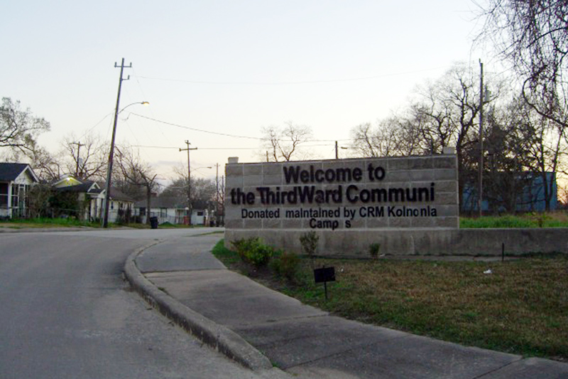
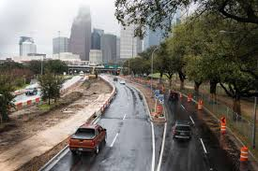
WRITTEN DESCRIPTION

The street intersects with Elgin, South more, Holman, and Wheeler. It is a section in Houston, Texas, in the United States. The community here has a population of approximately 1.4 million, the average age of the residents being 30 years. The community enjoys various demographic and physical features. Residential apartments majorly surround the community. However, there are few commercial activities, thus a few commercial streets.
The community has a variety of educational facilities inclusive of the elementary and the tertiary schools. There are ample public parking facilities in the community, and the majority are accessible by walking or biking. There are enough pavements, and much of the geographical area is green, where the majority of the area is covered by trees, although there are no many agricultural practices. There are adequate security facilities; thus, the crime rate is low in the community.

REFERENCES
Callary, E. (2020). Texas Place-Names. University of Texas Press.
https://www.google.com/imgres?imgurl=https%3A%2F%2Fs.hdnux.com%2Fphotos%2F44%2F41%2F66%2F9575824%2F5%2F1200x0.jpg&imgrefurl=https%3A%2F%2Fwww.chron.com%2Fnews%2Fhouston-texas%2Fhouston%2Farticle%2FThese-are-the-name-origins-of-Houston-s-iconic-11110386.php&tbnid=mg6xGFkrcXcCSM&vet=12ahUKEwjU4f_DjeDsAhVW4oUKHU6wAuwQMygLegQIARA_..i&docid=qOUnTJ7-zrve7M&w=1200&h=799&q=Cullen%20Blvd%20between%20Elgin%20St%20and%20Wheeler%20St%20environmental%20health&ved=2ahUKEwjU4f_DjeDsAhVW4oUKHU6wAuwQMygLegQIARA_
Sansom, A., & Reaves, W. E. (Eds.). (, 2017). Of Texas Rivers and Texas Art. Texas A&M University Press.

